Use-Case Specification: Manage Rooms

Version 1.0

Revision History

|  |  |  |  |
| --- | --- | --- | --- |
| **Date** | **Version** | **Description** | **Author** |
| 24/11/2024 | 1.0 | Final Version | Nguyen Huu Dang |
|  |  |  |  |
|  |  |  |  |
|  |  |  |  |

Table of Contents

1. Use-Case Name 4

1.1 Brief Description 4

1.2 Actor 4

2. Flow of Events 4

2.1 Basic Flow 4

2.1.1 Add room 4

2.1.2 Update room 4

2.1.3 Delete room 5

2.2 Alternative Flows 5

3. Special Requirements 6

4. Preconditions 6

4.1 Add room 6

4.2 Update room 6

5. Postconditions 6

6. Extension Points 6

7. Prototype 6

7.1 Add room 6

7.2 Update room 7

7.3 Delete Room 9

Use-Case Specification: Manage Rooms

# Use-Case Name

## Brief Description

This use case describes the process of managing rooms, including adding a new room, updating an existing room, and deleting a room.

## Actor

Administrator.

# Flow of Events

## Basic Flow

After successfully logging in as an admin, the user is directed to the Admin Page, where they gain access to manage all rooms, including tasks such as adding, updating, and deleting rooms. They can click on the **Manage Rooms** button on the left-hand side to see the room list.

### Add room

When the admin clicks the **Add Room** button on the top right corner, the system displays the Add Room Modal. On this modal, the admin adds images for the room and enters details such as the room number, room type, room floor, price, facility, and status for the new room.

After entering the information, the admin clicks the **Save** button located at the bottom of the modal. The system checks for the room's existence, if the room is unique, and the information is valid, the system adds the room and shows a success message. If the room already exists, or any information is invalid, the system displays an error message to offer the admin to reenter the information or cancel the process.

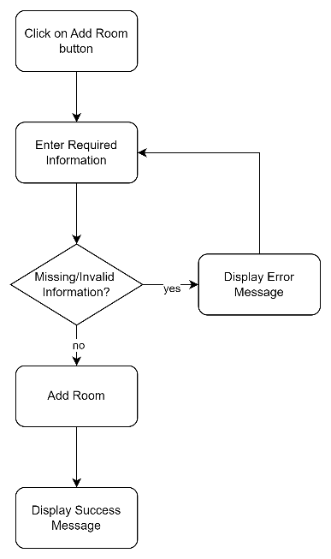

### Update room

On the room list, when the admin clicks the edit icon on the right-hand side of each room, they see a popup with 2 options: **Update Room** and **Delete Room**. When the admin selects **Update Room**, the system displays an Update Room Modal and the admin can change the existing information of the room such as images, type, number, floor, price, facility, and status. After editing information, the admin clicks the **Save** button located at the bottom of the modal. The system then checks for the validation of the new information. The system updates the information and shows a success message if the information is valid. Else, the system displays an error message to offer the admin to reenter the information or cancel the process.

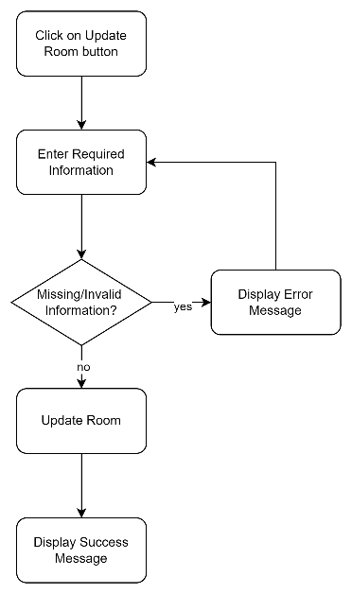

### Delete room

On the room list, when the admin clicks the edit icon on the right-hand side of each room, the system displays a popup with 2 options: **Update Room** and **Delete Room**. Then the admin selects **Delete Room**, the system displays a Delete Room Prompt to confirm the deletion. The admin clicks **Sure** then the system deletes the room and shows a success message to notify the admin.

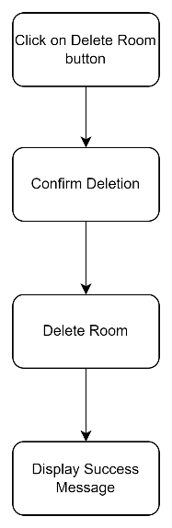

## Alternative Flows

None.

# Special Requirements

None.

# Preconditions

The user has successfully logged in as Administrator.

## Add room

The room number and room name has not been in the database. All attributes of the new room are valid.

## Update room

All attributes of the new room are valid.

# Postconditions

Information about a new room, the updated room, and the deleted room is updated on the database.

# Extension Points

NA.

# Prototype

## Add room

1. The admin clicks on the **Manage Rooms** button to see the room list, clicking on **Add Room** button to add a new room

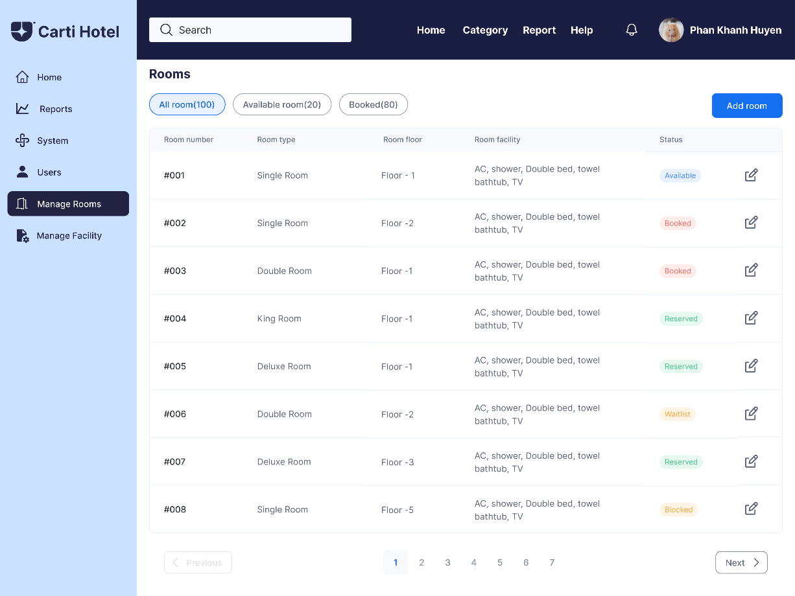

2. After the admin clicks the **Add Room** button, an Add Room Modal is displayed.

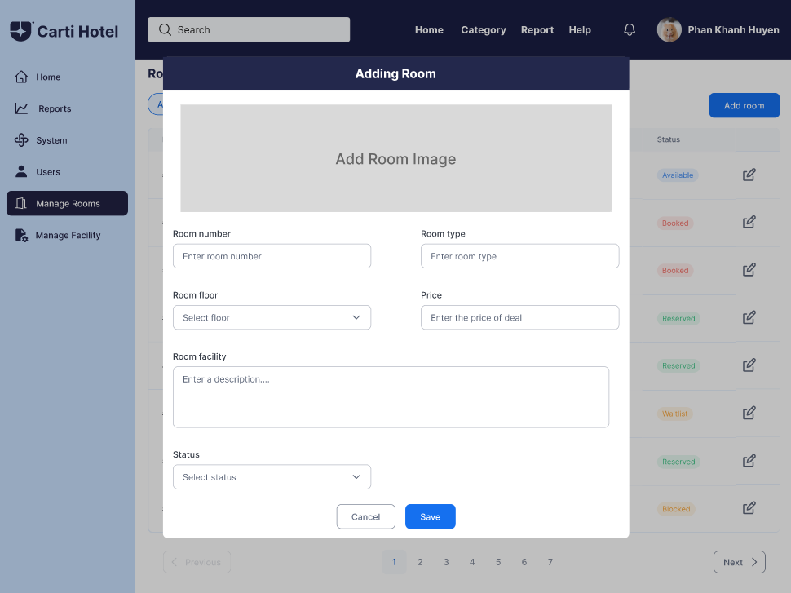

3. After filling the information and clicking **Save** button, a message is shown to notify the admin of the adding success or failure

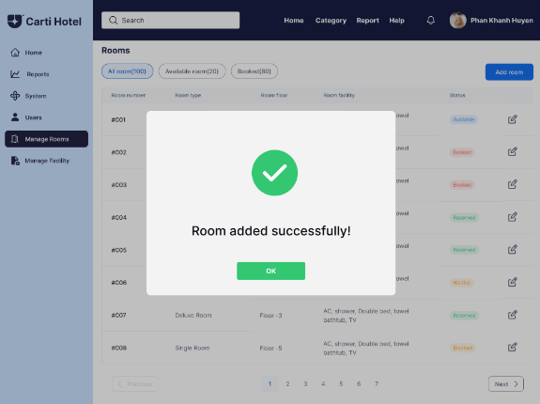 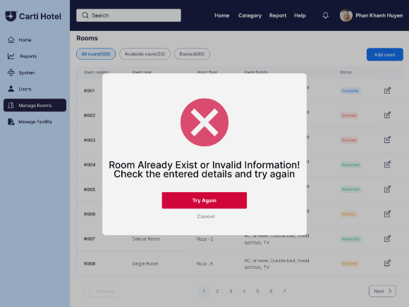

## Update room

1. The admin clicks on the **Manage Rooms** button to see the room list, clicking on edit icon to see **Update Room** and **Delete Room** options, then clicking on **Update Room** button to see Update Room Modal

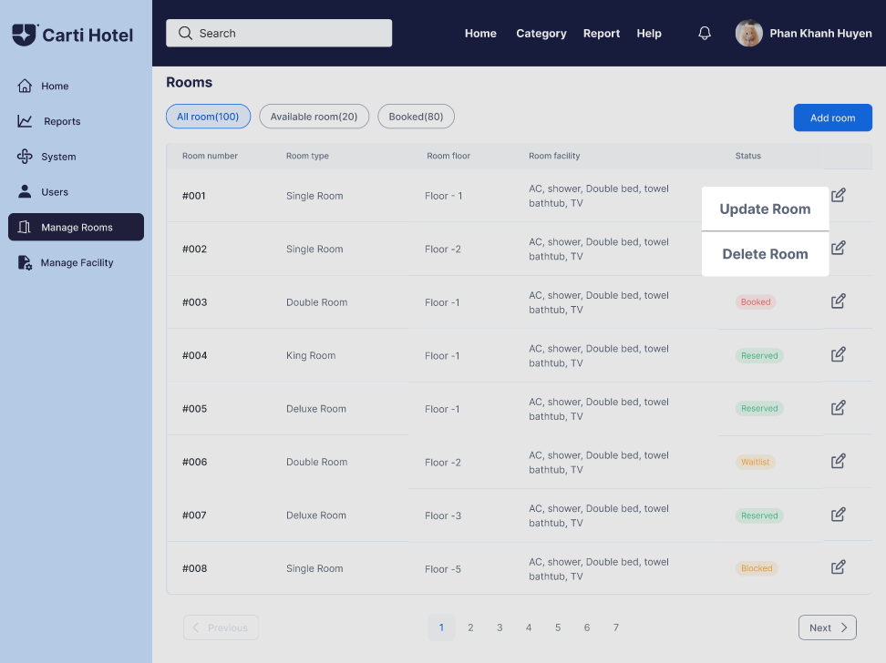

2. On the Update Room Modal, the room information is displayed, the admin changes the existing information and click on **Save**

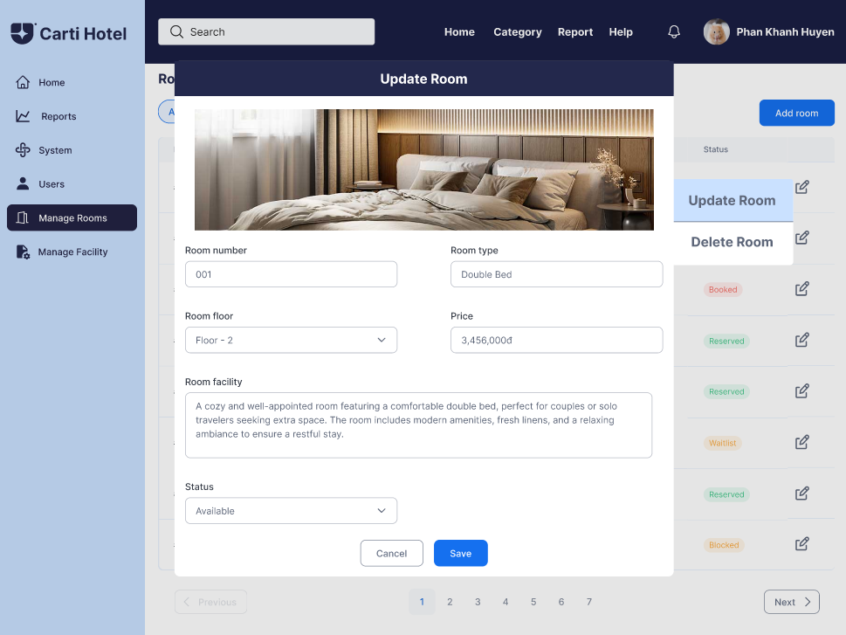

4. After clicking on **Save**, the admin is notified about the success/failure with a message

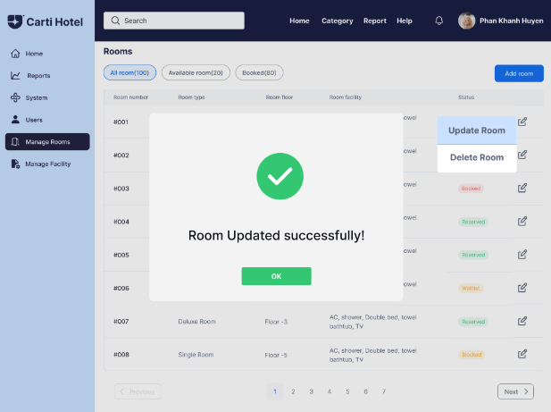 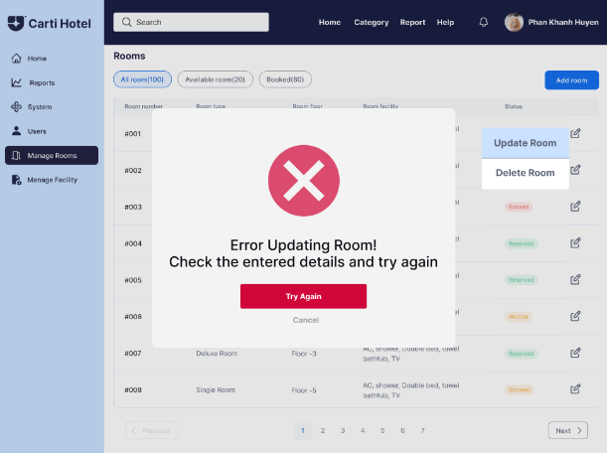

## Delete Room

1. The admin clicks on the **Manage Rooms** button to see the room list, clicking on edit icon to see **Update Room** and **Delete Room** options, then clicking on **Delete Room** to delete the room



2. A Delete Prompt is shown to confirm the deletion

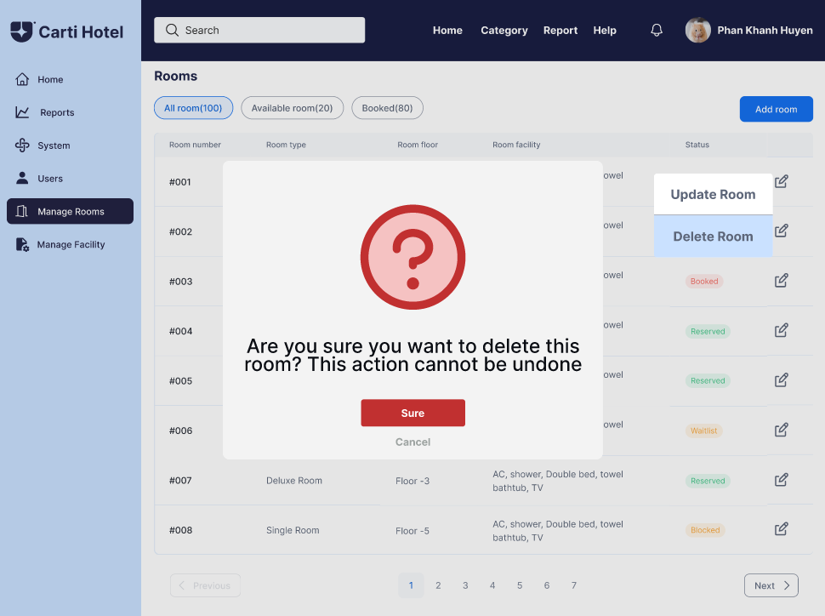

3. The admin clicks **Sure** to confirm the deletion, then a message is shown to notify the successful deletion

